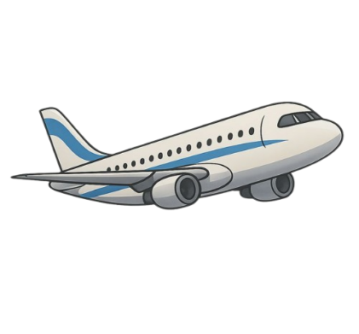
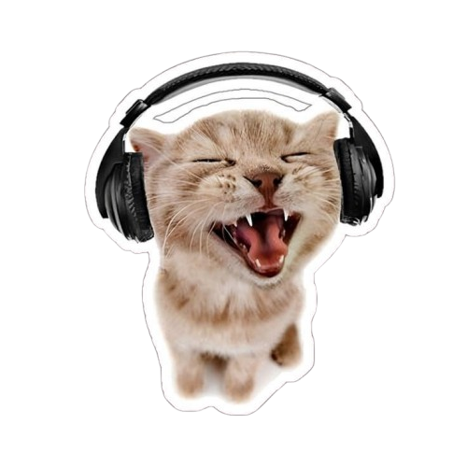
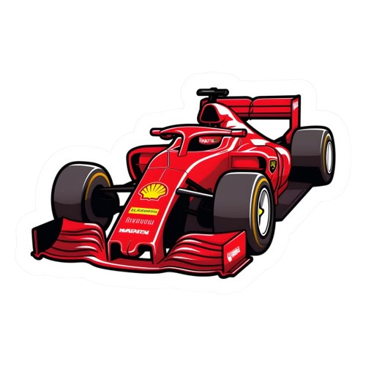
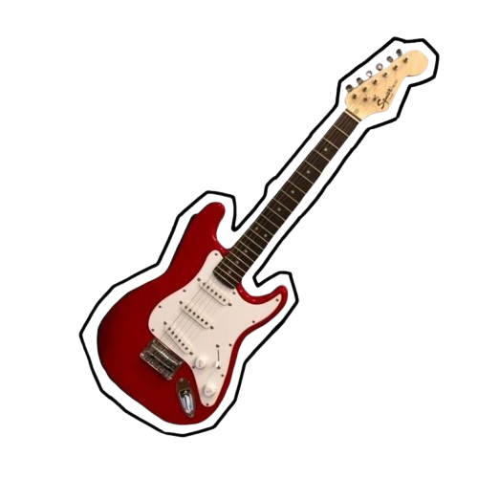

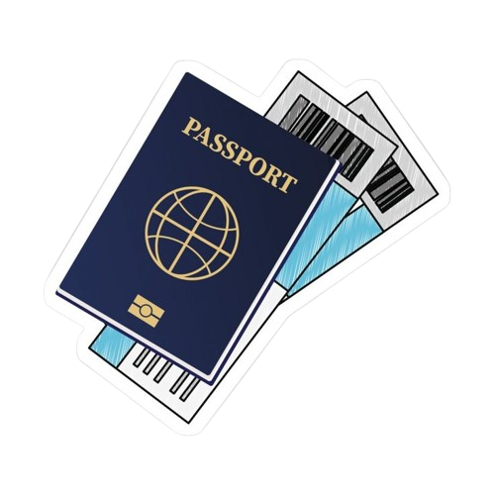
- Toothbrush
- Toothpaste
- Face cream
- Deodorant
- Hairbrush
- Soap
- Daily medicaments
- Small towel
TOILETRIES
- Headphones
- Travel guides
- Book
- Umbrella
- Refillable bottle
- Cotton bag
- Camera
- Power bank
OTHER GEAR
- Socks
- Light trousers
- Shorts
- T- shirt
- Long sleeve shirt
- Sweatshirt
- Shoes
- Light blazer
- Hat + sunglasses
CLOTHING
- Passport
- Hotel confirmation
- Wallet
- Cash
- Phone + charger
- Travel insurance
ESSENTIALS
Holiday Check List

Holiday Check list

